25th August 2017

**YOKOHAMA’s ADVAN Sport V105 to Come Factory-Equipped on Subaru WRX STI**

YOKOHAMA has begun deliveries of its global flagship “ADVAN Sport V105” tyre for use as the original equipment on Subaru’s WRX STI, which was released on 20th June after a major redesign. The WRX STI will come equipped with 245/35R19 89W size tyres in Japan and overseas.

The “ADVAN Sport V105” was developed for high-power premium cars and delivers excellent driving performance combined with superior comfort and safety characteristics.

The WRX STI epitomizes the sporty performance of Subaru’s all-wheel drive vehicles, combining sports car performance with the practicality of a four-door sedan. The redesigned model’s new electronic control system and larger inner diameter tyres enhance the car’s driving and safety performance.

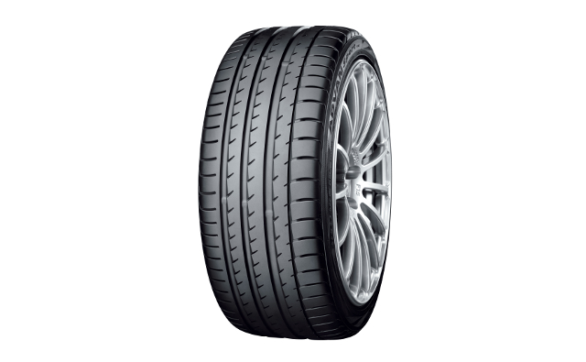

“ADVAN Sport V105” Tyre shown in photo differs in size from those installed on the WRX STI. (a wheel shown in the photo is not standard equipment)